# Return to Chaos

A light glows around you like white fire.

**Play Catacombs**

When it disperses, you are standing in the cellar of a Temple. You see dinner cloths and robes sewn with an emblem. The emblem is a circle of seven stars.

Religion check to realize its for Mystra, Goddess of Magic. The cellar is dusty and dust collects on nearly every surface. Cob webs decorate the walls, but the spiders have long since left. There are a 3 full flasks of what looks like water with the circle of stars on it, as well as 6 empty flasks laying in front of the door. 4 are cracked.

A skeleton lies on the floor, cuddling an empty bottle of wine. It is wearing robes with the circle of stars on it.

There is a stair case that leads to a wooden door. The door looks to be cracked, as if someone tried to bust in.

The door is locked. (but the key is in the robes of the skeleton)

The cellar opens up into a long stone hallway. The walls and door are gouged with deep scratches, and the floor is spotted with small, dry red dots.

It is brisk and cold in the cellar. So much so that you can see your breath.

The hallway stretches out, showing 2 doors on either side of the hallway, with a wrought iron spiral staircase leading upward at the end of the cellar.

Say: it doesn’t look like this room has anything useful

One room has a bunch of broken wine bottles.

One room is completely empty, except for a holy symbol on the wall, a mat with the circle of stars on the floor, and an incense burner.

One room has a few cots stacked on top of each other, for storage.

**It appears as if there is a large cat wearing clothing sleeping on top of one.**

One room has a few Mystra prayer books stacked on a desk.

The spiral stair case leads up to a platform with a blue door.

The door opens up into a sanctuary with a nave attached. The candles, unlit and dusty, are completely melted down, leaving wax piles on the unkept floor. The pews, the alter and floor look to be unused for quite some time. 2 skeletons lay in pieces on the sanctuary, and dried blood is smeared around.

The door leading outside is piled up with pews and anything else heavy.

If they inspect the room, they will feel a small breeze coming from the opposite side of the alter, which leads to an open door. Otherwise, they can just go out the front by moving all the shit.

# Silver Rose

**Play Haunted Town Creepy Ambience**

The city of Silver Rose looks to be destroyed. Houses have burned down or have been ripped apart. Others have candle light glowing out of cracks in boarded up windows. Ice is struggling to survive in the shadows under the winter sun. You can still see your breath in the brisk air. You may not be dressed for the occasion.

You recognize this as the northern most part of town, close to the exit you took to go to Serenity Garden. You can hear signs of life, but the streets appear empty.

**What do you do?**

You do see life in the city. Most people you talk to are weary of you, but trust the ‘human’ wearing the holy symbol. They will ask you for help lifting a board, holding it level, or nailing it in.

“The undead happened. They keep coming in hoards. The first attack was 7 years ago. Our best soldiers and city watch were able to keep them out of the city, but at a great cost. The second attack was worse. By the 3rd attack, we barely had any soldiers to protect us. I couldn’t even tell you how many undead came through those gates…. everyone died…or was eaten. Those of us that remain have cellars to hide in. But even that isn’t enough these days…”

A strong odor of urine, body odor, and other unpleasant smells overwhelms your senses.

“YOU DIDN’T BELIEVE ME ABOUT JERGAL!” a sudden yellow erupts from behind you. It is the old lady from your first visit to Silver Rose. Her ratted white hair and yellow teeth look worse than before, if that’s even possible. “I told you this devil was trouble *velhalla*. And now we will all die! You should pray to jergal. Maybe he’ll just let you die rather than allow that bitch to turn you into a puppet.”

*will talk about Jergal. Her name is Tulip.*

## Silver Vine Inn

The doors have been coated in steel and a thick gate has been put up around the entry way. Two guards stand watch over the gate.

“Who goes there!” One of the guards shout, holding a spear towards the gate.

**Wait for response**

David is dead, but Mary Margret is still there. She has aged drastically.

The other guard is younger. His name is Elis. He keeps giving Velhalla and Ellena a strange look.

**Play Heroes Inn**

The food is mostly rationed at this point. They offer you small cups of soup and a small piece of bread. Barely enough to fill your stomach. They tell you how hard finding food has been lately.

There are a lot of people in this inn.

You recognize Rejak, from Richochet Armaments. The enormous man is helping haul large iron bars upstairs. The rooms upstairs are open to the outside so they are gating them up.

You see a tiny pixie (sorcerer) flying around the room as well.

Mary Margaret is helping another woman clean up dishes that have been left on the inn’s tables.

A strange looking group is sitting at a table that includes an Fire Genasi (wizard), An Elf (Possessed Ranger), a Human (Barbarian) and a Kenku (Rouge).

Vincent gets a strange feeling from the Elf.

A woman is sitting over in the corner. She has two tattered banners with houses on them next to her

* 1 bed house: 1,000gp
* 2 bed house: 1,500gp
* (nobleman’s house) 5 bed house: 3,500gp
* (mansion) 30 bedroom house: 25,000gp

Overall, the inn still looks well-kept. It’s obvious the residents are taking the time to clean.

**What do you do?**

**Ella wants to go see Taoba**

## Talos Temple

**Play Holy Temple**

This temple is very similar to Silver Vine. A large, tall gate has been constructed around the entirety of the circular building. There is no guard outside.

Upon walking up to it, Ella begins to play her lute, the one Nasoj gave to her in the Crystal Caverns, and signs. It takes a few minutes, but eventually Taoba comes running out.

“Ella, is it really you? And Ellena, and Velhalla! Where’s Nasoj? Who are these three?”

Taoba is spewing questions frantically as he struggles to open the gate. The Talos priest, still dressed in black robes with a lighting bolt sewn on, looks skinny, but healthy.

He talks about how Kallista came back years ago and said she had waited outside the Fey for weeks before assuming you were dead. She’s been joining up with fighting parties and going out to defend the city or find answers. Each time she returns, she returns alone and with fresh wounds. She’s been gone quite some time now. She is due back sooner or later, if she’s even alive.

He asks what you plan to do now?

He offers to go with you.

## Other

There is not a lot else to do in Silver Rose

# Leaving Silver Rose:

The gates to Silver Rose are heavily mended, with loose pieces of iron or wood nailed over the gates to cover holes.

As you open the gate, you see the familiar silhouette of a rouge dressed in tight leather walking towards you. The leather is torn in several places, exposing deep cuts in the rogue’s pale skin. Despite her wounds, her glowing yellow eyes are as radiant as ever.

**What do you do?**

**Play Haunted Town Creepy Ambience**

## Kallista

Kallista doesn’t seem happy to see your crew. She expresses minimal surprise that you’re still alive and disdain that you left her with a dwarf for weeks.

Thu’mer died, she thinks. She decided to leave long before he would even consider leaving Nasoj. But as she made her way to Silver Rose, a hoard of undead was making its way North. As a Rogue, she was able to sneak past them, but she doubts a clumsy, hot headed dwarf was able to survive.

She offers you a drink, and retrieves a couple bottles of blackberry wine from her leather back pack.

“I want to recruit your help,” she says, taking a large swig of the wine. The alcohol seems to be her safety blanket

“I don’t think the Talos temple, the one in the mountains, has lost its usefulness yet. The temple has been regarded as the most impenetrable temple in the world. Not only does the natural perils of the Storm’s Rage Mountains protect it, but Talos and other gods look over the mountains themselves. However, I don’t believe it was always a Temple to Talos. A shrine may have once existed in the mountains, worshiping a god of light and life, Lathander, and may hold a relic that can stop the undead.”

DC 18 to detect deception or DC 15 arcana check to question it or DC 20 arcana check to know that the Talos temple was built over a temple to Jergal, when Jergal was still god of death. When Myrkul (then Cyric, then Kelemvor) took over, the temple was abandoned and the clergy, known as the Scriveners of Doom, moved to an unknown location.

“I would appreciate your help, but we’ll move faster in a small group. Taoba has already agreed to come. Ella, can I count on you?”

Ella nods

“Velhalla, Ellena, how about you?”

“We’ve come so far. It will be nice to travel with a familiar face,” Velhalla says, smiling at the two pretty girls in front of her.

“Perfect. A warrior, a rouge, a bard, a forest dweller, and a cleric. What more could we need” she says, smiling.

*Say goodbyes as the other party leaves for the temple to get Taoba* *Will see if they can create or re-activate a transportation circle in the temple*

**Play Dark Tavern – Goblin King’s**

The Silent Plains now reflect their name more than ever before. The once green grass is now glazed with ice that reflects the light of the winter sun. The scarce trees that lightly dot the plains have grayed and abandoned their leaves for the winter. Their sleeping branches are lightly dusted with powdery snow.

The chilling wind bites at your faces, familiar only to Vincent who grew up in the White North region of the Storm’s Rage mountains. Even at it’s brightest, the sun struggles to break through the snow and ice.

**What do you do?**

# To Demon’s Hearth

Your walk is cold, but pretty. Overall, it is uneventful as the sun makes its way across the sky.

Find a place to begin to rest as the sun makes its final decent. Eat food.

The frost seems to be collecting more as the sun retreats. The bone chilling cold is beginning to take over your body. The long trudge in the cold has exhausted you.

*END OF DAY*

**What do you do?**

If sleeping, the sound of rapidly approaching footsteps awake you. You can see a large group of individuals charging in your direction. **What do you do?**

**Play Darkest Dungeon**

If in Plains, lots of zombies attack. (8 zombies, 2 Wight)

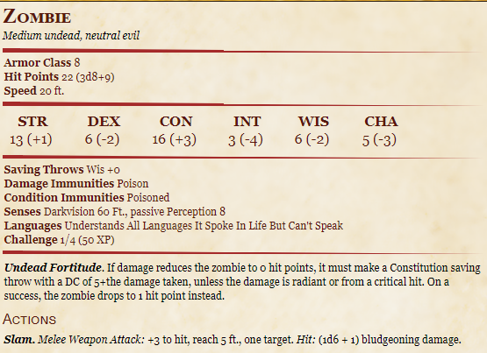

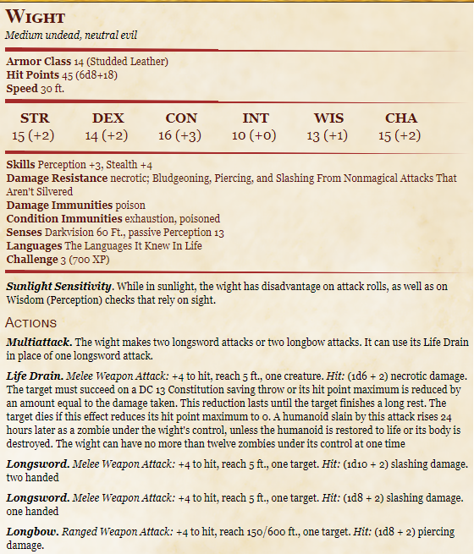 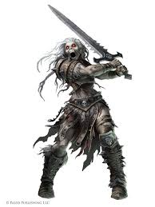

The [creature] shrieks in pain as it falls. The screams stretch across the Plains, like a call to arms from a fallen soldier. Your heart beats faster as the scream is answered in the distance in multiple directions.

**What do you do?**

Fight at least 8 more zombies and 2 more Wraith. Keep em coming until they’re almost dead (so Artemis can help)

Off to the West, you can see a couple lights glowing off in the distance, very close together. It is probably over half a mile away, so you cannot make out what it is, even with dark vision.

**What do you do?**

## The Farm House

**Play Ravenia (it has a lead in so play it here not later)**

As you approach the lights, you realize that it is candle light coming from the windows of a farmhouse.

The light is barely lighting up a wooden fence with stakes pointed out, threatening anyone who dares run too close. A thundering *neigh* echos from in front of you. The largest horse you’ve ever seen gallops towards you, a hooded figure on its back. In front of you, a gate has opened in the wooden fence.

As you run, the horse rushes by you. You can feel the force of its movement as it cuts the air next to you.

The rider begins swinging a giant flail, lit ablaze, in vertical circles at their side. The giant, black horse plows fearlessly into the pack of undead behind you. The fiery flail knocks it’s enemies to the ground as the warhorse crushes their limbs and chest with it’s massive hooves. Black armor covering the mount protects it from the claws and teeth of the undead.

It’s not long till the pack is slain.

The rider turns their stead and lightly gallops back towards you. The flail rests at the ready in their hand, but the fire has dissipated. They are getting quite close.

**What do you do?**

### Artemis

The hooded rider, dressed in all black, stares down at you from the back of their horse. The horse’s back is easily 6ft off the ground. The rider’s face is wrapped in black cloth, hiding everything but their piercing eyes. You can see a fresh scar cutting over their right eye. Finally, the rider and the mount begin taking off inside the fence. They motion for you to join them.

As you walk into the rider closes the fence behind you. You can see the outline of vegetable and fruit beds leading up to the farmhouse.

The rider points at the farm house door, but takes their mount over to the stable.

**What do you do?**

The inside of the farmhouse is well kept. The windows have been reinforced with wrought iron, similar to those in Silver Rose. A pot is boiling over a well-lit fire. It is obviously stew, and it smells amazing.

The rider enters the room, their moonlight gray eyes staring suspiciously at you. They take off their cloak, revealing a slender but muscular silhouette standing about 5ft 4in tall. The bandages covering the rider’s face seem to wrap around the length of their body, as well.

The rider backs up slowly into their kitchen area and retrieves enough bowls for all of you, including the Boggle, plus themself. They put the bowls on the table, all the while keeping their eyes on you.

You hear something coming from the loft above you. (there are a few children in the rafters that Artemis is protecting)

“How are you still alive?” They ask, muffled by the cloth. It is a girl’s voice. You can hear the weight of her pain in her breath.

Everyone in Willow’s Watch is dead. Her overly paranoid father taught her how to fight, how to grow crops, how to hunt, and how to do everything else she would ever need. He died protecting the farming village when the War of the Undead began. Her mother passed a few years after from disease.

Her community worshipped Chauntea (NG, Life, Sheaf of Grain emblem) goddess of agriculture. But her mother was from Demon’s Hearth and worshiped Pelor (NG, life and light, sun emblem) god of sun and healing. Before her mother passed, she prayed to Pelor to protect her daughter. The girl felt a calling to wonder into the desert. She found a stone baring ruins of ancient times. When she dug, she found a flail and black bandages.

The bandages make her immune to slashing or piercing damage, and if a wound is bandaged with them, it will stop you from dying but will not heal the wound.

It was a gift from Pelor.

Her name is Artemis. Her horse is Stranger. Artemis is very young and although she is very talented, she is also very scared.

She offers to let you sleep here for the night. She also says that the farming village of Willow’s Watch was decimated easily. Afterall, farmers aren’t made for fighting the undead. She says you should look through the village to see if there’s anything you could need.

She’s spending her time riding Stranger to various farming villages to see if any of them have any survivors. She says if you find any survivors on your journey, she will take them in.

*DAY BEGINS*

## Willow’s Watch

10 things of rations. Wool sweaters for everyone. 10cp, 12cp, 3sp, 1gp, and 5cp x 10. Crop seeds.

A single chicken comes walking up to you and stares at you expectantly.

The chicken will follow you for some time. EAT FOOD

## Day 2

*DAY ENDS*

Find shelter somewhere or else the zombies will strike again. EAT RATION

*DAY BEGINS*

## Day 3

About an hour into your day you begin to hear weird ticking noises, like a clock. You can see a rocky hill side far in the distance. There are strange things on the tops of the hills.

(if they roll a perception check DC 10) you notice a weird metal…mouth?...poking out of the ground. It quickly burrows back in and the ticking stops.

This happens again and again.

*mid day – eat* You can see a strange looking tower with a pointed roof in the distance, but can’t tell what it is. The things on top of the hills look like large wooden posts with 4 paper-like wings that spin in a vertical circle. As the wind speed changes, so does the spinning speed.

As you begin to approach a rocky and hilly countryside, a much louder ticking can be heard. Suddenly, a large cobra slithers down a hill. But it is not a normal cobra. It is purple and appears to be made of metal.

The ticking gets louder and louder as the cobra moves towards you, it begins to hiss but the his is very mechanized.

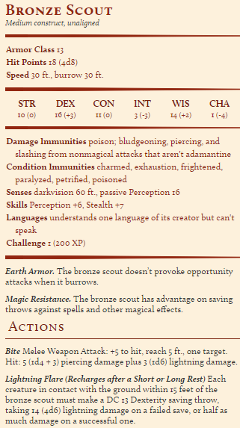More ticking begins to join in as several of the bronze-metal mouths being popping up out of the ground, reveling large mechanical worms x7. THEY DO NOT ATTACK WILLUM!

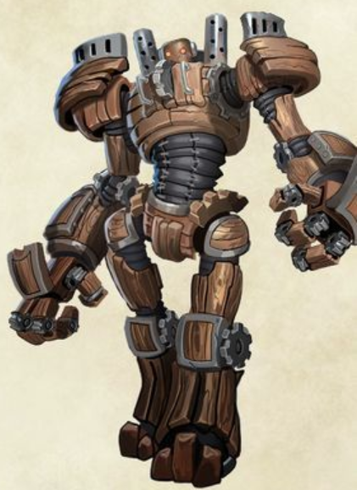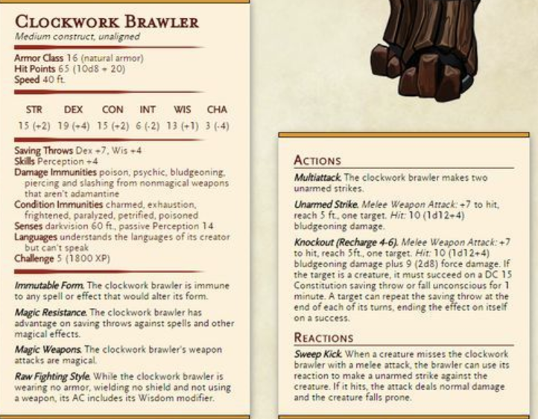Once they clear out all of these, they hear very heavy mechanical footsteps. Two large bronze androids come marching slowly around a hill. The ticket gets even louder as they approach.

**What do you do?**

As you look forward, it is still unclear what the tower is.

## Rivvenastorp (no transportation circle)

After your run in with these strange creatures, you find yourself in a strange but magical village. Tiny houses residing in the rocky hills are quaint and whimsical. It is still chilly, and the grass at the bottom of the hills are lightly covered in ice. Some of the rocks have ice hiding in their crevices as well. It is nowhere near as cold as in Silver Rose, however.

Lots of gnomes walking around. They all stare at you funny. You notice these strange wooden pools protruding out of the ground. They almost look like lampposts, but there’s nowhere to light it.

You see

* A couple kid Gnomes playing with tops (like spinning tops) that when spun, zoom 100ft into the air and then land back on the ground, still spinning.
  + They say Zimzam gave it to Pipper (one of the boys) for his birthday
* A large tower (by Gnome Standards) that has a white circle with numbers 1-12 on it. It looks like a sundial, but there are two sticks protruding from the center. A gnome is cleaning it.
  + The Gnome says Zimzam built this clock so everyone could see what time it was. It made the sundial obsolete!
* Two lady gnomes shouting that they have the best stew in town.
  + Made with Zimzam’s Stewmatic.
  + You may buy a bowl for 5cp.
* A heafty gnome is standing between two blue banners with a picture of a house on each one.
  + He will sell you a house for 125,000gp (but the house has full electricity, indoor plumbing, etc.)
  + Zimzam added this ‘elec-teresty’ (mispronounce electricity) thing for the entire town. The windy thingies catch the wind and make other things work.

Direct to Zimzankatan. Zim created the monsters to protect from the undead. However, he couldn’t really get them to ONLY target the undead, so they settled for ignoring gnomes instead…He’s peeved that you broke their security feature.

You can buy some interesting things. And stay the night in a hotel. The hotel has a lot of cool things, like lights that don’t require flame, warm water that doesn’t require a fire underneath it, and boxes that play music when wound up.

### Patches

In the morning, you return to see Zimzam. There is a tall, skinny man in a blue robe talking to Zimzam in Gnomish. His skin is discolored in patches, as if pieces from various humans were sewn together. He has a long white beard and two different colored eyes.

If you speak gnomish, you notice that his gnomish sounds old. Like the way your great-great-great-gnomefather would have spoken. It’s actually kind of hard to understand.

Zimzam is asking the man if he knows where to find a Brocart Filaments and Cortosis substrate. He needs more Fibrous Nylie Solution and Conductive Flux to get the damn thing working. The man responds by saying that Brocart Filaments are typically found in flesh of a jumping cholla (cactus) and the Cortosis substrate can be extracted from the fat of a Froghemoth (volo’s guide)

### Amorette and Mr. Picklepaws

There is a cutsy wizard gnome that works for Zimzam. She’s quite young and very hyper and eccentric. She loves learning how to make clockwork stuff, and has figured out how to infuse magic with them. She has an intelligent pet river otter that she calls Mr. Picklepaws.

*DAY ENDS*

# Demon’s Hearth

*DAY BEGINS* *EAT*

The ice is completely gone as the fertile soil begins to turn to sand, but the chill in the air still lingers. Quickly, as you walk, the sand turns soft and nearly white, swirling in small tornados in front of you.

You can go South-West to the Tiefling village and potentially Sandstone.

You can go South to the Desert of Dragon’s (dragonborn community)

You can go South-East in search of the temple ruins.

## Abydos – Tiefling Village

It is over near the southern Storm’s Rage mountains.

The walk is long and uneventful. Even cactus don’t reside in this part of desert. The sand is soft and hard to walk in and gets in your boots and pretty much everywhere else.

As the sun begins to set, you begin to hear the howls of wild dogs. The way the sound carries over the sand is eerie, but nothing unexplainable.

It has been another log day of walking. The desert, although the frost of winter has no power here, is rapidly getting colder as the sun begins to set. Discomfort sets in at the temperature change and your empty stomachs beg for food. You are still 2 hours away from the village.

**What do you do?**

You can hear creatures moving around your party. Low grows begin to surround you.

Suddenly, a large, black dog charges at you. It’s massive, muscular body is only overshadowed by the fact that it has two large, snarling heads. One of the heads is missing an ear.

The creature lunging at you invites the others to do so as well. You count 8 of these dogs. (Alpha has more HP and +1 attack and const).

Notes: If you throw your rations, it will go away.

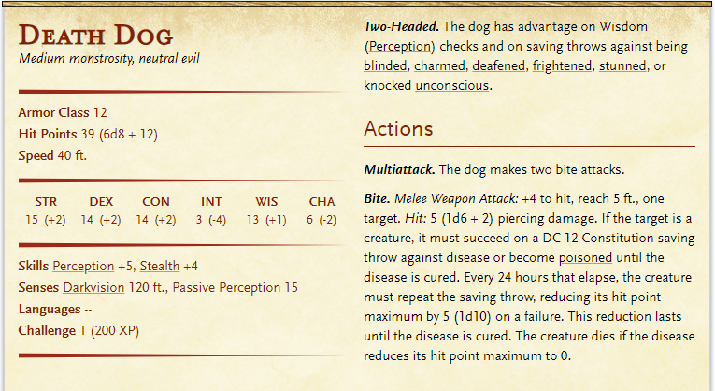

The village is carved out of the red mountain rock in a desert cove. Carved stair cases, worn from the years, lead up half a dozen levels. Windows and doors are left open with only cloth and thin wooden panels protecting from wandering eyes and sand.

In the center of the cove is a bazaar. Open air vendors offer the strangest foods, such as bread as black as night, cactus fruits in pinks and oranges, pies cooked like dumplings with strangely spiced meats, and roasted duck on spits.

Tieflings of all regards are wondering through the town. Some are so pale they look nearly human, while others are so dark red they are nearly black until the sun hits their skin. Black hair, purple hair, and red hair seem to be the most common, and horns of all types and shapes are decorated proudly.

There are all sorts of people on the street other than the vendors

1. Children playing with dragon wood dolls (speak infernal only)
   1. Tell you that brass dragons and blue dragons live in the desert, even though no one has seen them. Brass dragons are nice, but blue dragons are mean.
   2. Blue dragons will eat you but brass dragons would rather trade.
2. A man wearing bones yelling something in infernal
   1. A witch doctor. Will sell you a potions that:
      1. Rots your flesh and makes you appear undead forever, but your insides are unaffected (6gp)
      2. A Feign Death scroll (lv 3 spell, 500gp)
         1. You make someone appear dead for 1 hr
         2. Need a pinch of graveyard dirt (V, S, M)
         3. Target is blind and incapacitated
         4. Resisted to everything but psychic damage
3. 3 different groups talking in the streets
   1. None will speak to you and look at you with disgust
4. A Tiefling man wearing a tattered cloak. It has an emblem that [Katie’s Character] recognizes from many years ago when her parents were killed.
   1. He says he bought it years ago off 3 humans and a drow
   2. The drow was obviously in charge, and had a scar over his right eye
   3. He doesn’t know anything beyond that…
   4. He says that he’s seen the symbol before when he was a child, though. He was playing close to the desert temple while his father was on a raid. He saw the symbol on armor outside the temple…
5. A Bard Tiefling is yelling “Step right up! Win gold! Fill your pockets!”
   1. He says you can wager any amount of money you want up to 1000gp. If you can answer 3 questions, he will double your winnings (2000gp). If you miss even 1 question, you lose all the gold.
   2. REMINDER: THIS IS DND LORE, NOT JASON LORE
   3. THIS IS PERSONAL KNOWLEDGE. AKA METAGAMING
      1. What 2 things can kill a vampire?
      2. How does a Lich come to be?
         1. Wizard or what not makes an item that allows them to be immortal in death.
      3. What is the name of the pass that most people take through Storm’s Rage Mountains?
      4. How many main types of Hags are there? 5
      5. What two types of dragons typically live in the desert?
      6. How many silver pieces are in a gold piece?
6. A wealthy looking Tiefling stands between two banners with houses sewn on them.
   1. He will sell you housing for:
      1. A 1 bed house halfway up the mountain: 7,000gp
      2. A 2 bed house on the lower levels: 13,000gp
      3. A 5 bed house at the top of the mountain: 100,000gp

Someone they interact with must tell them to follow the rising sun. It is directly east from the village. If you don’t waver from east, you will find it. If you do, you may never leave the desert again.

You may stay at the inn for normal pricing

## Desert of Dragons (blocked off for the moment)

The Desert of Dragons is quite far. (do same dog scenario if they did this first and not Abydos).

About 2 hours into your walk, you see a wall of sand up ahead. Balsimar recognizes it as a sand storm. These storms can last anywhere from an hour to a week. Trying to pass would be incredibly difficult.

## Temple Ruins

3 day hike. 3 days of food.

The walk seems to take forever, but at least you’re not being attacked by undead. In fact, it doesn’t appear as if anything is alive or dead in this part of the desert. The winter sun still makes your hike unpleasantly warm, but not enough to kill you.

The beautiful dunes and swirling sands of the desert are quickly growing old, as sand fills your shoes, your mouths and everything else. Sleeping proves to be exceptionally uncomfortable, as you find yourself waking up, half buried, from desert winds blowing sand around. A tent is a nice haven.

A couple hours into your 3rd day of walking, you begin to notice the ground changing texture. Replacing the soft dunes, the ground begins to feel harder, more like sun baked clay with a small layer of sand over it.

As you approach, you see two sets of foot prints. One is headed north-east, the other goes directly south.

**Where do you go?**

### The southern path

After a few hours of walking, you find yourself at a beautiful oasis. The water is clean and crisp, and green palm trees provide shade. There is even luscious grass that would be perfect for napping or having a picnic on.

As far as you can see, as there are no longer dunes in your path, there is no one else around. However, there also doesn’t appear to be a desert temple here.

It is getting close to dusk.

**What do you do?**

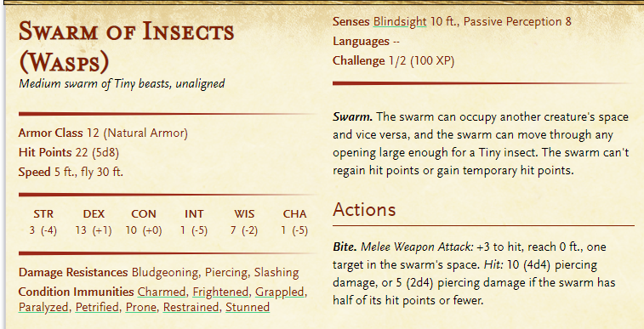When night hits, the sound of buzzing locus sounds like a melodic lullaby luring you into sleep.

The sound begins to get louder and louder. The hair on the back of your neck stands up.

Those of you with darkvision can see a wall of darkness coming at you from a distance. As it approaches, the sounds gets louder and louder.

Swarms of locus force their way into the oasis.

### The north east path

You come across a random building with a well outside of it. It looks as if the building may have been a church at one point.

The inside of the building is are 6 pews lined up in on each side (12 total) in front of an altar. On each of the pews, you see a minimum of 2 skeletons, and up to 4 skeletons. Each skeleton is dressed in the nicest clothes a peasant could afford, but has been tattered and withered from years of decay and extreme heat.

**What do you do?**

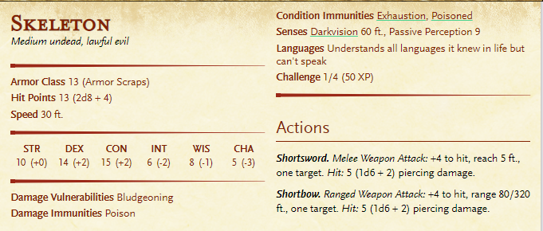The skeletons look at you. 25 skeletons. They can peace out and the skeletons wont follow.

### Continue East like They’re supposed to.

As you continue walking, you notice a second set of footprints, identical to the first, headed in the same direction.

These footprints continue to appear ahead of you for miles, luring you off into other directions.

However, you begin to see a building, appearing as if a mirage, off in the distance, about 3 miles out. It is beginning to get dark.

**What do you do?**

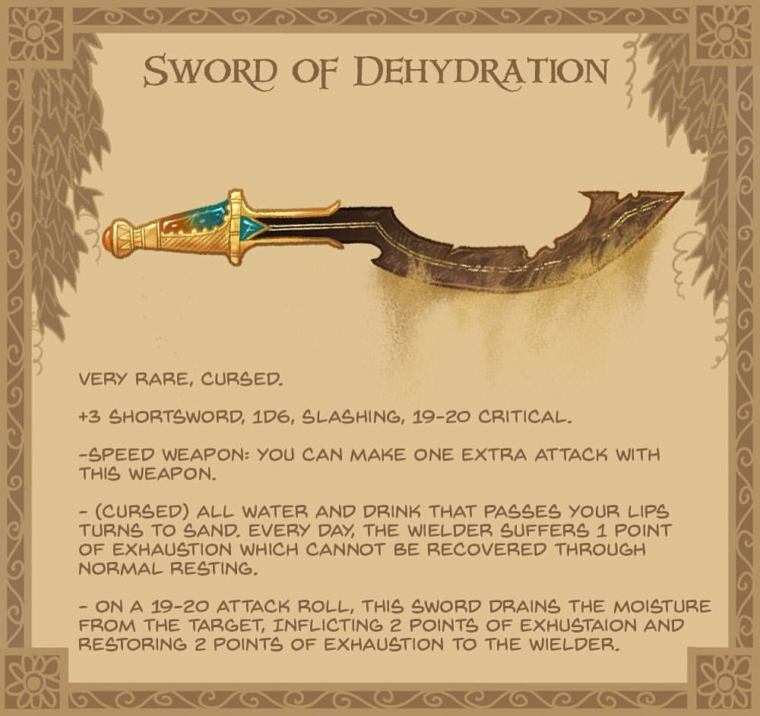

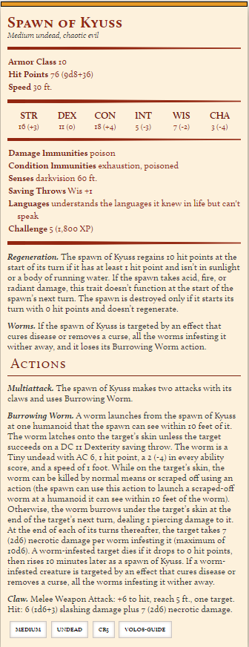

A gynosphinx can turn back time

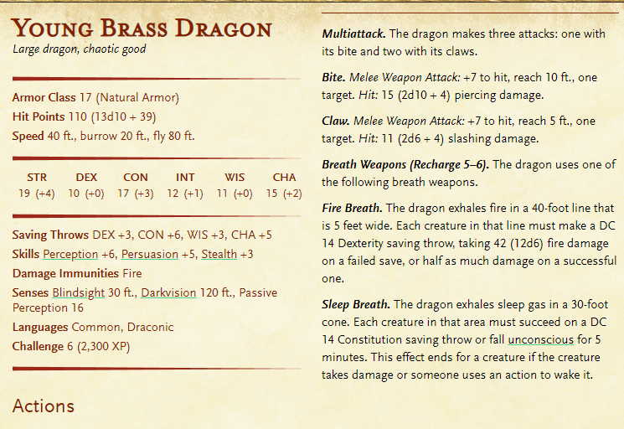

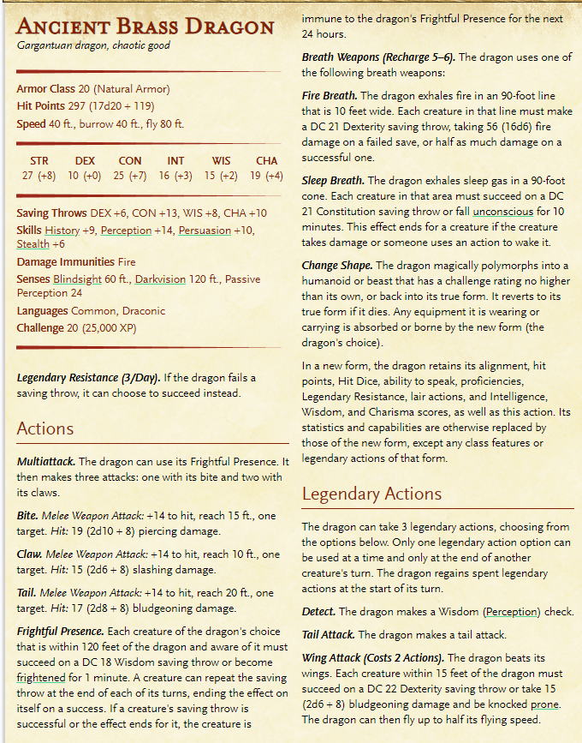

### Xiathus’ Lair

#### Lair Actions

On initiative count 20 (losing initiative ties), the dragon takes a lair action to cause one of the following effects:

* A strong wind blows around the dragon. Each creature within 60 feet of the dragon must succeed on a DC 15 Strength saving throw or be pushed 15 feet away from the dragon and knocked [prone](https://www.dndbeyond.com/compendium/rules/basic-rules/appendix-a-conditions#Prone). Gases and vapors are dispersed by the wind, and unprotected flames are extinguished. Protected flames, such as lanterns, have a 50 percent chance of being extinguished.
* A cloud of sand swirls about in a 20-foot-radius sphere centered on a point the dragon can see within 120 feet of it. The cloud spreads around corners. Each creature in it must succeed on a DC 15 Constitution saving throw or be [blinded](https://www.dndbeyond.com/compendium/rules/basic-rules/appendix-a-conditions#Blinded) for 1 minute. A creature can repeat the saving throw at the end of each of its turns, ending the effect on itself on a success.

#### Regional Effects

The region containing a legendary brass dragon’s lair is warped by the dragon’s magic, which creates one or more of the following effects:

* Tracks appear in the sand within 6 miles of the dragon’s lair. The tracks lead to safe shelters and hidden water sources, while also leading away from areas that the dragon prefers to remain undisturbed.
* Images of Large or smaller monsters haunt the desert sands within 1 mile of the dragon’s lair. These illusions move and appear real, although they can do no harm. A creature that examines an image from a distance can tell it’s an illusion with a successful DC 20 Intelligence ([Investigation](https://www.dndbeyond.com/compendium/rules/basic-rules/using-ability-scores#Investigation)) check. Any physical interaction with an image reveals it to be an illusion, because objects pass through it.
* Whenever a creature with an Intelligence of 3 or higher comes within 30 feet of a water source within 1 mile of the dragon’s lair, the dragon becomes aware of the creature’s presence and location.

If the dragon dies, the tracks fade in 1d10 days, but the other effects fade immediately.

### Xiathus

### Desert of Dragons

You can see a large, natural, red-stone wall in front of you; a smaller mountain range branching off from Storm’s Rage. You cannot see either end of them.

**What do you do?**

Balsimar remembers there is a valley that goes through it.

Long story short, during the day you are attacked by a pack of Gnolls (hyena-headed humans). Not enough to kill them all but enough to weaken them. The sun begins to go down and the Gnolls suddenly pull back. Que 2nd wave of undead Gnolls.

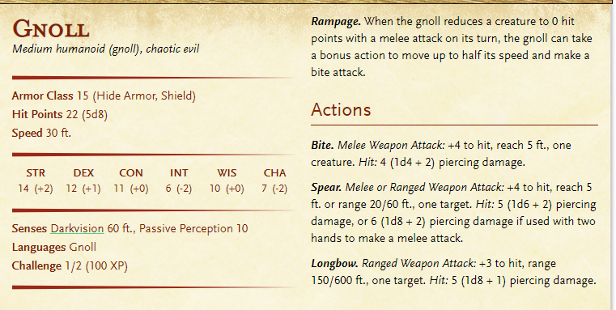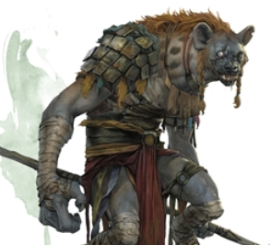

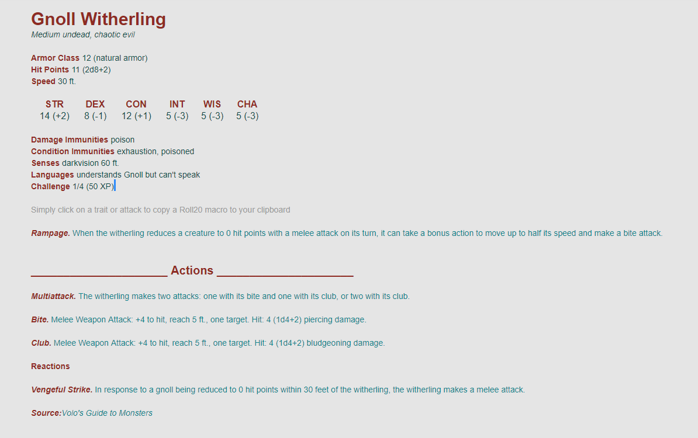

The dragonborn clans in the desert of dragons frequently move around the desert, staying in one place for merely a night or two.

However, Maystan exists as a central and permanent city adjacent to a beautiful Oasis. It is about half a day’s walk from where you are.

The city is absolutely beautiful. The clay brick houses are built around a large blue pond. Green palm trees provide shade and beauty.

The weather is nearly perfect. The cold chills from winter mixed with the hot sands of the desert and create a very pleasant atmosphere.

The dragonborn are eyeballing you strangely. They seem to be surprised by their presence. Very few visitors enter the Desert of Dragons.

* Go to temple and get a mini mission. Go kill the young blue dragon that has been terrorizing the town
  + This would give you cool dragon harvesting things
* Learn more about brass dragons
  + They like gifts
  + They like conversations
  + They like stories
* Kill the deathlocks (dead Dragonborn warlocks)
  + Find a bottled demon in one of their cloaks

